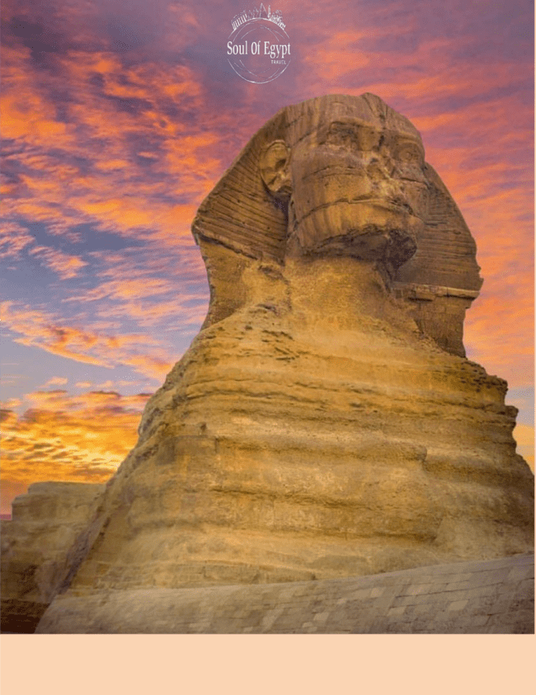

Project Camelot

April

2025

*Day 01: 23rd Of April: Arrival – Welcome to Egypt:*

Welcome to the land of Pharaohs! Upon arrival our friendly rep. will be waiting for you to meet, greet & assist you throughout airport procedures, and then you will be transferred to your chosen hotel for overnight.

**Meals: NA / Overnight: Four Seasons First Residence or similar.**

*Day 02: 24th Of April: Sakkara – Overnight hotel in Cairo:*

We will take you for a guided trip to “**Step Pyramid of Sakkara**” one of the most extensive archaeological sites in Egypt! It was the cemetery for Memphis, the capital of Ancient Egypt, yet it is still one of the virgin archaeological sites, despite the fact that so much has already been found here! “The Step Pyramid of King Zoser”. **Optional Private visit to Abu Gurab**.

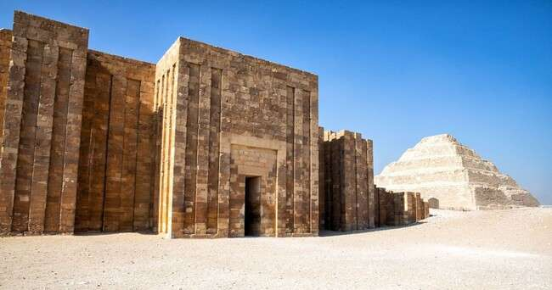

**Meals: Breakfast / Overnight: Hotel in Cairo – Four Seasons First Residence Hotel or similar.**

*Day 03: 25th Of April: Private Visit at The Sphinx & Private visit at Giza great pyramid:*

We will have a private visit to **The** **Great Sphinx**, the guardian of the Pyramids, Feel the energy of the spirits… Then we are off to discover some of the most awesome wonders of the World to touch them and

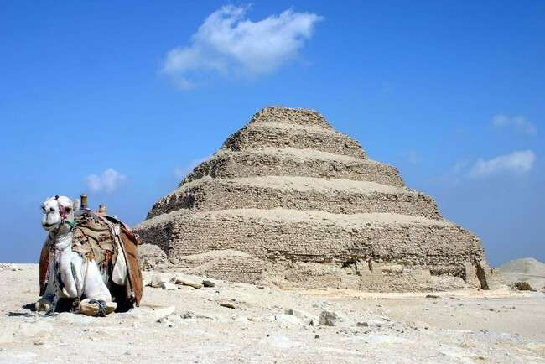to feel them here the Pyramids of the Giza Plateau. Our guide, who is an encyclopedia of Egyptology, will give us detailed examinations of various controversial theories surrounding these amazing structures.

That is not all for today, we will have a visit privately inside the **Great Pyramid** with a culminating initiation in the King’s chamber. Here, we unite our life story with the story of those who have come before us and those who will come after as we embrace the transformation that we have experienced.

**Meals: Breakfast / Overnight: Hotel in Cairo - Four Seasons First Residence Hotel or similar.**

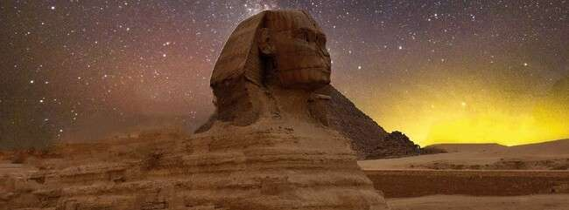

*Day 04: 26th of April – Egyptian Museum & Fly to Luxor:*

After breakfast you will meet up with your tour guide at the lobby to start an interesting trip to the “**Egyptian Museum**” housing more than 160’000 piece of antiquates. Afternoon will be free at your disposal. Evening flight to Luxor. Arrival & transfer to your chosen hotel in Luxor.

**Meals: Breakfast & Dinner / Overnight: Steigenberger Nile Palace Luxor Hotel or similar.**

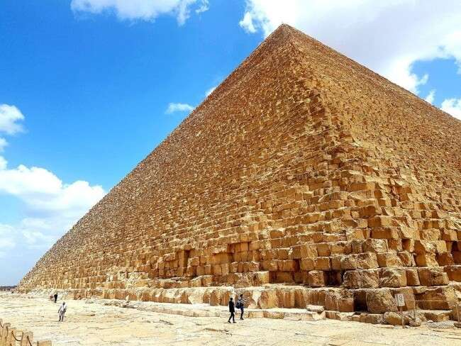

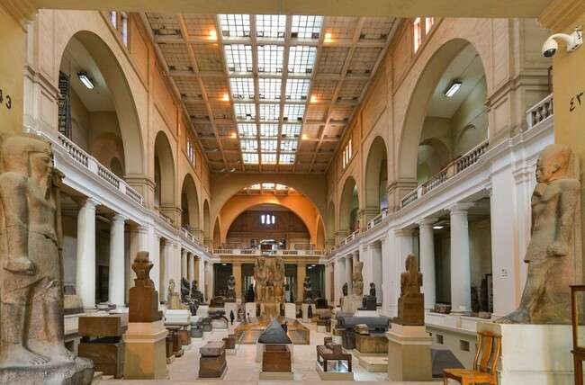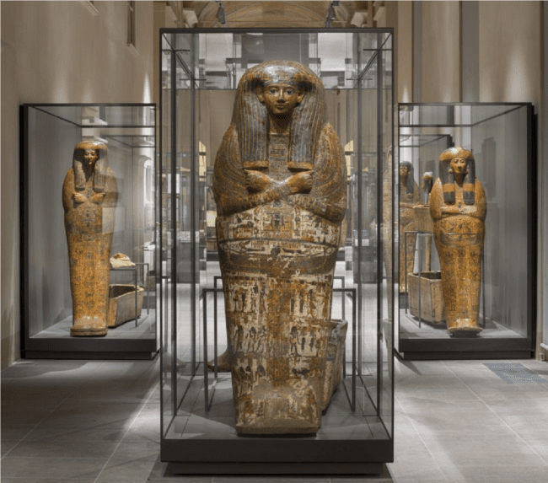

*Day 05: 27th of April – East Bank in Luxor:*

Start our trip with a visit to **“The Temples of Karnak”**,considered as the largest Temple in the

World! The complex contains a group of Temples such as the Great Temple of Amon Ra, The Temple of Khonso, The Temple of Ptah, the Temple of Montho and the Temple of the God Osiris. A 20m high, mud brick enclosure wall, surrounded all of these buildings. On the Bank (East Bank of the Nile); will head to **“Luxor Temple”** it is huge in scale — it once housed a village within its walls. It has several pylons (monumental gateways) that are some 70 yards long. The first pylon is over 70 feet high, fronted by massive statues and several obelisks. There are several open areas, once used for various forms of worship but now empty. Later additions include a shrine to Alexander the Great, a Roman sanctuary, and an Islamic shrine to a 13th-century holy man.

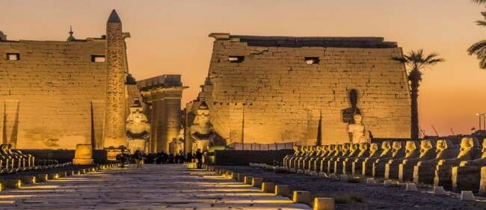**Meals: Breakfast & Dinner / Overnight: Steigenberger Nile Palace Luxor Hotel or similar.**

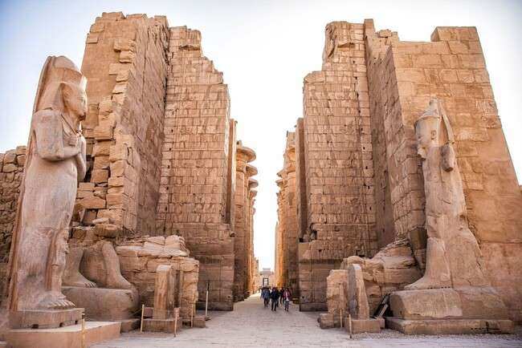

*Day 06: 28th of April - Dendera & Abydos:*

After breakfast will start with an early drive North from Luxor & head to **“Abydos Temple”,** dedicated to Seti I, Osiris and Isis along with Ptah, Ptah-Sokar, Nefertem, ReHorakhty, Amun, and Horus, is one of the major archaeological sites in that region. It was begun by Seti I and finished by his son, the great Ramesses II. In fact, this structure built of fine white limestone is actually one of the most impressive religious structures in Egypt. Will take you to **“Dendera Temple” or “Temple of Goddess Hathor**”, this Temple complex contains the Temple of Hathor, is one of the best-preserved temples, in all of Upper Egypt.The whole complex covers some 40,000 square meters and is surrounded by a hefty mud brick wall. The present building dates back to the times of the Ptolemaic dynasty and was completed by the Roman emperor Tiberius, but it rests on the foundations of earlier buildings dating back at least as far as Khufu (known as the Great Pyramid builder Cheops, the second Pharaoh of the 4th dynasty [c. 2613–c. 2494 BC]) but it was the pharaoh Pepi I Meryre who built the temple. It was once home to the celebrated Dendera zodiac, which is now displayed in the Louvre Museum in Paris. After we are done with the visits, will take you to the cruise dock where you will check in for a magnificent 4 night’s trip sailing from Luxor to Aswan.

**Meals: Breakfast, lunch & dinner / Overnight: On board Sonesta St. George Nile Cruise or similar.**

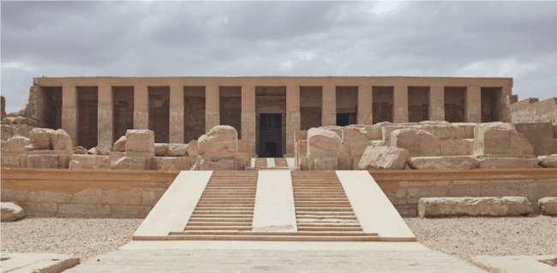

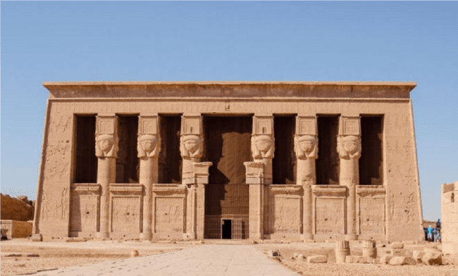

*Day 07: 29th of April – West Bank in Luxor:*

Get up early in the morning to avoid the noontide heat of the West Bank, head to **the Valley of the Kings** with its numerous tombs and chambers. Only fifteen tombs out of 63 are open for public, among them are those granted to Tutankhamun, Thutmose III, Ramesses I and Seti II.Visit the massive twin statues depicting the Pharaoh Amenhotep III widely known as the **Colossi of Memnon, Queen Hatshepsut,** where you can learn the tale of the divine birth of the first female king.Sail to Esna by noontime.

**Meals: Breakfast, Lunch & dinner / Overnight: On board Sonesta St. George Nile Cruise or similar.**

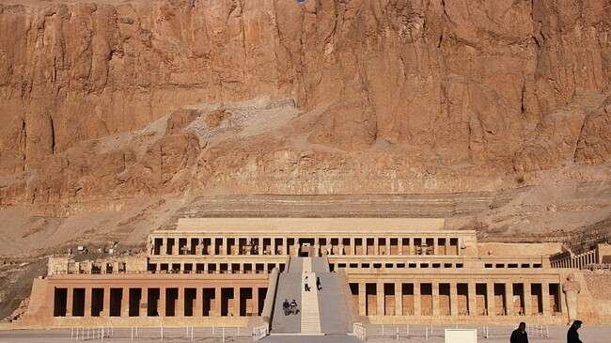

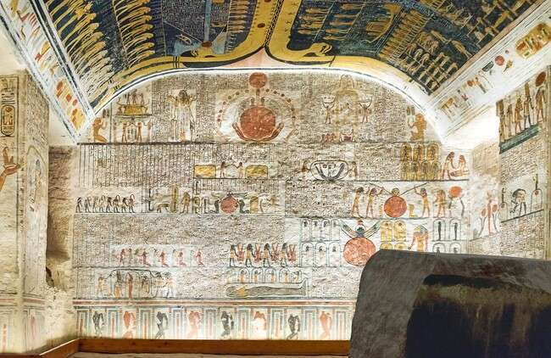

*Day 08: 30th of April– Sail to Edfu - Kom Ombo Temple*

Breakfast on board; visit the remarkably well-preserved **Temple of Edfu** or as known "The Temple of Falcon, consists of traditional elements of Egyptian Temples of the New Kingdom, together with a few Greek elements, such as the Mamisi. Set sail to Kom Ombo, after lunch we will take you to the unusual double **Temple of Kom Ombo.** Inspect the detailed friezes and hieroglyphs on the walls of the temple, dedicated to gods Horus and Sobek, or view the hundreds of preserved crocodile mummies displayed at the onsite museum

**Meals: Breakfast, Lunch & dinner / Overnight: On board Sonesta St. George Nile Cruise or similar.**

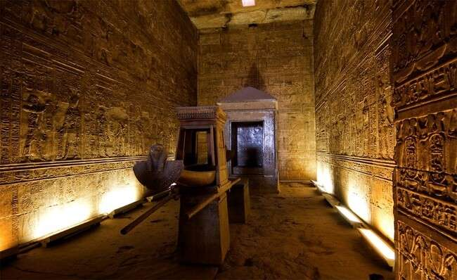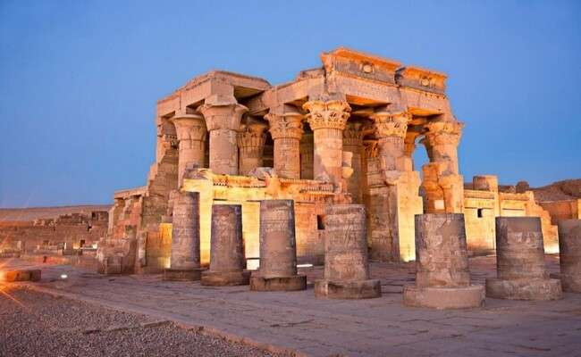

*Day 09: 01st of May – Sail to Aswan – Philae Temples:*

Early Sail to Aswan, arrival & a short sail across the river that will bring you to the Agilkia Island, where **the Philae Temples** dedicated to the Goddess Isis is currently located. Originally, the temple was situated near the First Cataract of the Nile River, though in 1902 when the construction of the Old Aswan Dam started, the area was flooded and the complex was moved. Night is free at leisure; you might like to go exploring Aswan's Famous markets in the evening.

**Meals: Breakfast, Lunch & dinner / Overnight: On board Sonesta St. George Nile Cruise or similar.**

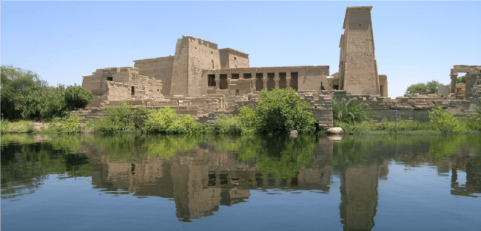

*Day 10: 02nd Of May - Fly back to Cairo - Grand Egyptian Museum:*

After breakfast we will transfer you to Aswan airport for the flight back to Cairo, upon arrival we will visit "**Grand Egyptian Museum**" the fascinating collections of antiquities, which now houses artifacts of [ancient Egypt,](https://en.wikipedia.org/wiki/Ancient_Egypt) including the complete [Tutankhamun](https://en.wikipedia.org/wiki/Tutankhamun) collection. Here many pieces will be displayed for the first time and it is considered the largest [archaeological museum](https://en.wikipedia.org/wiki/Archaeological_museum) in the world, holding the world's most extensive collection of Pharaonic antiquities. Then we will check in hotel.

**Meals: Breakfast - Overnight: Marriott Mena House Hotel or similar.**

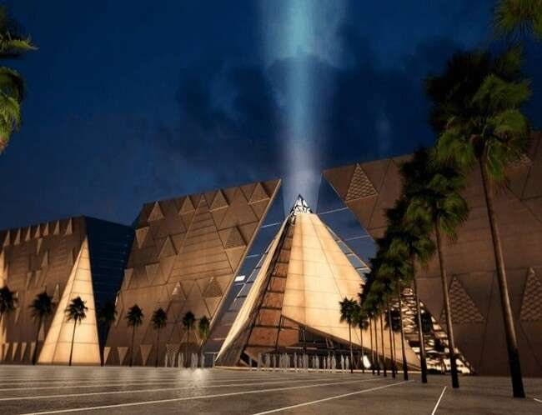

*Day11: 03rd of May - Departure:*

Breakfast and meet up with our friendly rep. for the transfer to Cairo International airport for final flight.

**“Itinerary might change due to unforeseen circumstances”**

“Private visits will be confirmed only as per the available timings by Ministry of Antiquities” “We might need to swap days, amend domestic flight ticket booking, change visits keeping the same included spots”

***INCLUSIONS***  ü Pick up & drop off transfers ü Transfers and Tours via deluxe Cars ü Meet, greet & assistance service ü 3 Nights hotel accommodation at **Four Seasons First Residence Hotel** or similar.

(Based on Bed & Breakfast) ü 2 Nights hotel accommodation at **Steigenberger Nile Palace Luxor Hotel** or similar.

(quoted on Nile View rooms based on Breakfast & Dinner) ü 4 Nights onboard **Sonesta St. George Nile Cruise** or similar sailing from Luxor to Aswan.

(Quoted based on Full Board) ü 1 Night in Cairo second stay at **Marriott Mena House Hotel** or similar.

(Based on Bed & Breakfast) ü Daily breakfast, starting the second day ü Daily lunch & dinner while on board cruise ü Farewell dinner

* Entrance fees to all mentioned sightseeing ü Private visit at Sphinx – 1 Hour
* Private visit at Giza Great Pyramid- Khufu – 2 Hours ü Relevant transfers
* Private English-speaking - Egyptologist tour guide throughout ü Domestic Flight ticket Cairo / Luxor - Aswan/Cairo

# EXCLUSIONS

* Entry visa, International Flight tickets from / to Egypt. ü Pre or post nights.
* Meals, other than the listed ones. ü Phone calls, laundry, personnel expenses, optional tours, beverage …etc.
* Tipping to cover staff at hotel, sightseeing, drivers, restaurant…etc. average is **U$D 300.00**, per person / per package, to paid directly to the tour guide and he will settle on your behalf.
* Tipping of your Egyptologist Tour Guide & Tour Manager. ü Optional Private visit to Abu Gurab ü Travel Insurance. ü Any unmentioned item.

***Main Package Rate:***

* **Group 10 Paying Guests**
* Rate per person / per package in double is **U$D 5670**.**00.**
* Single supplement is **U$D 1950.00** on the top of the rate. Ø rate per person / per package in single is **U$D 7620.00**

* **Group 20 Paying Guests**
* Rate per person / per package in double is **U$D 4970.00.**
* Single supplement is **U$D 1950.00** on the top of the rate.
* rate per person / per package in single is **U$D 6920.00**

* Rate per room per night in double or Single is **U$D 400.00.** for **pre nights** at Four Seasons.

* Rate per room per night in double or Single is **U$D 550.00.** for **Post nights** at Marriott Mena House.

* Optional tour Private visit to Abu Sir & Abu Ghurab, Rate per person is **U$D 300.00** for **minimum 10 Guests** including entrance fees, transportation and Jeeps for Desert.

* Kerry Cassidy & Maria Wheatley’s Trip: Free of charge for the whole trip, domestic flight tickets, excluding the international flight tickets & entry visa.

* Tipping **U$D 300.00** per person / per package excluding Egyptologist tour guide & Tour Coordinator.

## PAYMENT DETAILS

* ***Please settle 25% Payment upon register maximum by November 15th, 2024.***
* ***Please settle 25% Payment by December 15th, 2024. With primary rooming list.***
* ***Rest of Payment subject to be paid on January 15th.2025. to Secure all relevant bookings.***
* ***Tipping kitty – average is U$D 300.00 per person excluding tour guide tipping, to be collected by Tour Coordinator cash upon arrival.***
* ***Tipping of your Egyptologist Tour Guide & Tour Coordinator.*** ➢ ***Please find our bank details hereunder: -***

|  |
| --- |
| Bank Name: Credit Agricole Egypt |
| Branch Name: 007 Pyramids |
| Beneficiary: Soul Of Egypt Travel |
| Address: 23 Cairo Alex Desert Rd, El Haram, Giza |
| Postal Code: 12572 |
| Bank account: 11018400022837 (USD) |
| Swift Code: AGRIEGCX |
| IBAN: EG260036000100011018400022837 (USD) |

## CANCELLATION POLICY

***Cancellations should be forwarded to us in a written email.***

***The following charges will be applied:***

* ***180 days prior to arrival date, 25% from your tour price will be charged as cancellation fees. (plus bank fees).***
* ***90 days prior to arrival date, 50% from your tour price will be charged as cancellation fees. (plus bank fees).***
* ***60 days prior to arrival date, 75% from your tour price will be charged as cancellation fees. (plus bank fees).***
* ***30 days prior arrival date a 100% from your tour price will be charged as cancellation fees****.*
* ***For domestic flight tickets; cancellation fees will be applied as per the policy of the supplier.***

## SIGNING OUT OF THE TOUR

***If you have chosen to leave the tour, you will be requested to inform us in writing; you will receive a "Tour Sign out form". No refund is offered from our side for the leftover portion of the tour. "Soul of Egypt Travel" will have no accountability for banishment or any other expenditures which may occur due to such an event.***

## FORCE MAJEURE

***Soul of Egypt Travel is not accountable; nor legally responsible, will NOT pay you any reimbursement if our obligations have been affected by any unforeseen circumstances that we are not able to avoid. Hereunder; we will list examples but not limited items of the force majeure cases: War, threat of war, terrorist activities, civil discord with its consequences or the risk of such activity, riot, Esna lock closure while boarding Nile Cruise, natural or atomic disasters, fire, chemical or biological disasters and adverse weather, sea, ice and river conditions, and/or similar occasions.***

## Price Changes

***Egyptian Government tax, service charge, Entry Visa and Private Meet & assist at Cairo Airport may be subject to change without prior notice from the authorities; accordingly, should the applicable VAT rate, other taxes and / or levies as imposed by the Egyptian Government increase or decrease after the conclusion of this agreement, rates granted by Soul Of Egypt Travel will be readjusted accordingly.***